HTTP Script Recorder:

* Open Jmeter by clicking on the JMeter icon on the desktop in your practice lab.
* Right click on Test Plan.
* Click on Thread(Users) -> Thread Group.
* Right click on Workbench.

Click on Add -> NonTest Elements -> Http(s) Test Script Recorder

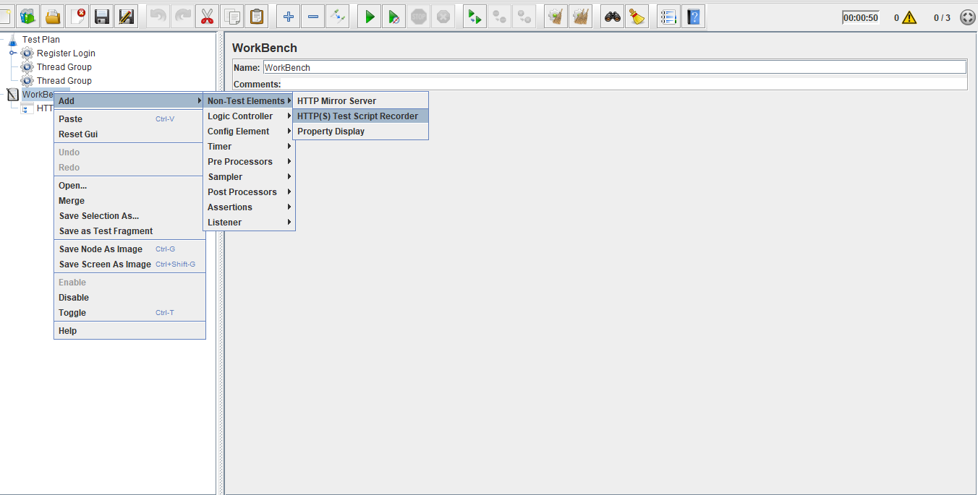

* Click on Add -> Logic Controller -> Recording Controller
* Click on Add -> Listener -> View Result in Tree

**Step -2 :**

Doing proxy settings in JMeter..we make changes in settings.

* Click on HTTP(S) Script Recorder.
* Set port number (optional).
* Click on the Start Button.

**Step – 3:**

Recording script using recording controller and using any page in chrome..

Once recorded we can test the script.

Output:

